Microwave Circuit Project Report

*Directional coupler microstrip line*

Student name - Matrikel

Ngoc An Ha - 967813

Nam Hung Le - 967826

Date

January 20th, 2015

Microwave Circuit Project Report

Directional coupler microstrip line

Design and implementation of directional coupler using microstrip line technique, Agilent’s Advanced Design System application and optimization.

|  |  |
| --- | --- |
| Center frequency | Coupling Coefficient |
| F0 = 2 GHz | C = - 10 dB |

Step 1: Calculate odd mode and even mode characteristic impedance.

Step 2: Create and simulate circuit using ideal couple line CLIN

Step 3: Transform to circuit using microstrip couple line MCLIN and use momentum simulation.

Step 4: Optimize circuit along with the discontinuities.

Step 5: Finish realizable circuit structure layout. Create the circuit.

Step 6: Using Network Analyzer to measure the result of the circuit. Compare the measurement result and simulation result.

# Formula and design

## Circuit

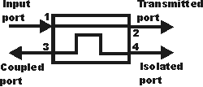

S11: Reflection coefficient

S21: Transmission coefficient

S31: Coupling coefficient

S41: Isolation

/S41-S31 /: Directivity

## Formula

F0 =2 GHz = 2.109 Hz

C= 10 dB = ${10}^{\frac{10}{20}}$ = 0.316

λ = $\frac{C_{0}}{F_{0}}$ = $\frac{{3*10}^{8}}{{2*10}^{9}}$ = 0.15 m

B = $\frac{2*π}{λ}$ = 41.888

l= $\frac{λ}{4}$ = $\frac{0.15}{4}$ = 0.0375 m

C= $\frac{Z_{Ce}-Z_{Co}}{Z_{Ce}+Z_{Co}}$ =0.316 => ZCe – ZCo= 0.316 * (ZCe + ZCo )

=> 0.684 * ZCe = 1.316 * ZCo (1)

Z02 = 502 = ZCe * ZCo(2)

From (1) and (2), we have

ZCo = 36.047 Ω

ZCe = 69.354 Ω

# Create circuit using ideal couple line CLIN



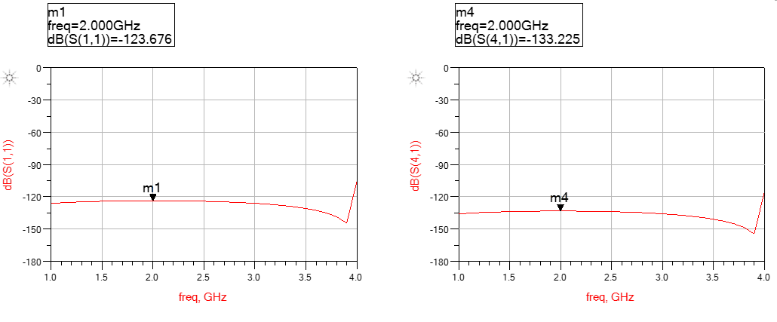

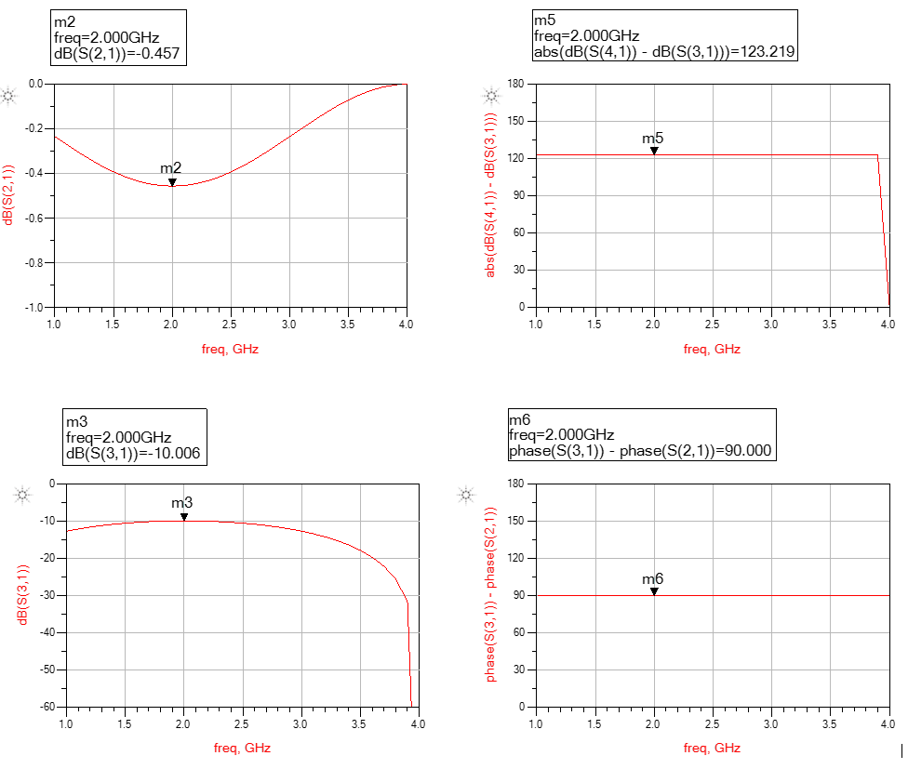

The simulation result show that at 2 GHz, we have coupling coefficient S31 at -10dB. This is a good result, since it show that our calculation results in Zce and Zco are right.

# Transformation to a structure with microstrip line component MCLIN

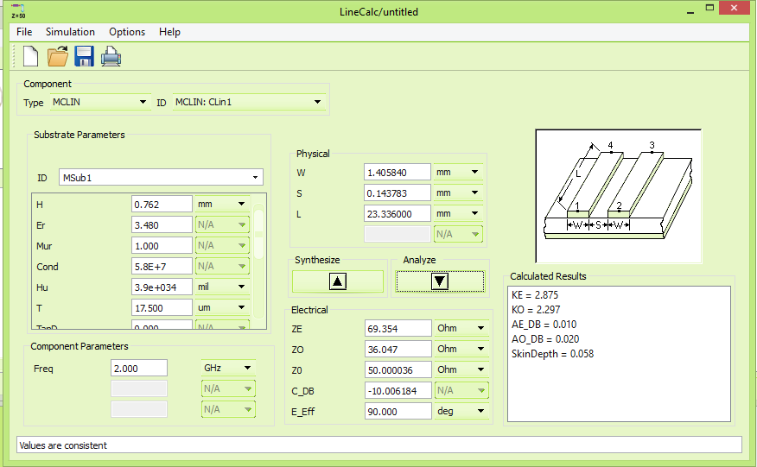



We would like to realize our circuit by using microstrip couple line elements. Therefore, we replaced CLIN by MCLIN.

Using the tool LineCal of ADS, with the Effective Electrical Length E_Eff of coupled section at 90 degree and center frequency at 2 GHz, we obtained the variable data for the Microstrip Couple Line. The reason we choose the E_Eff at 90 degree because from the design of the couple line method, each couple line must have $\frac{λ}{4}$ electrical length. In addition, for direction coupler, the phase between port 1 and port 4, as well as port 2 and port 3 is 90 degree.

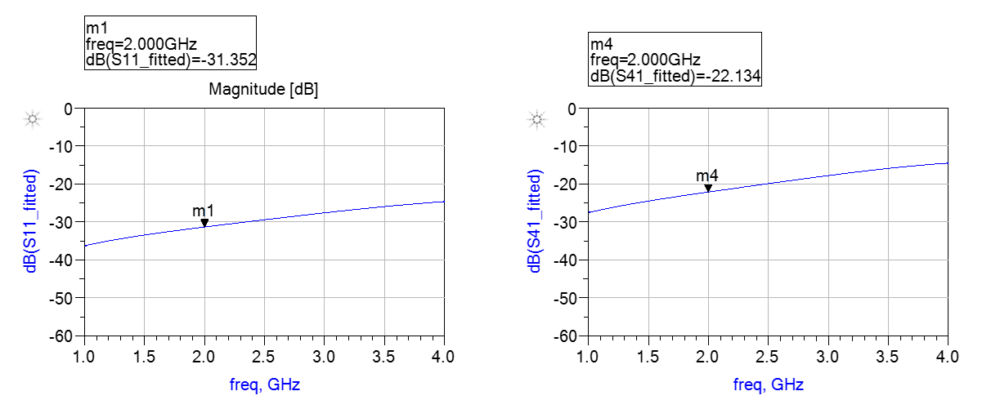

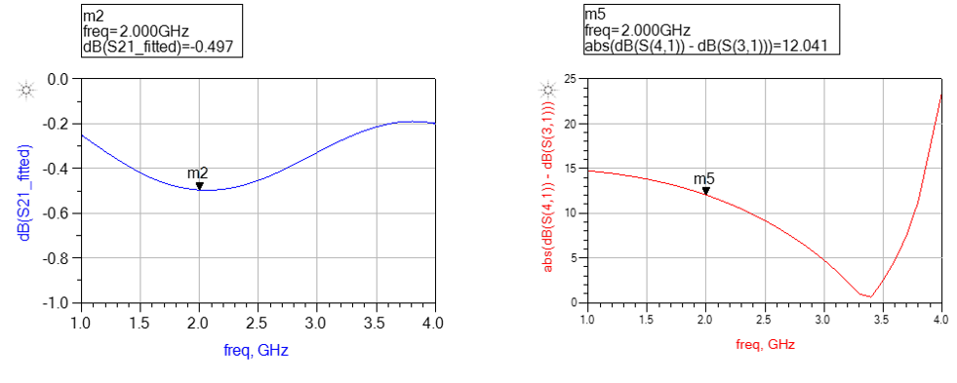

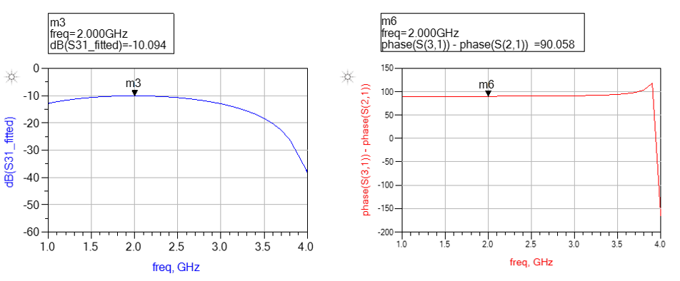

Judging from the simulation result, we can see that at 2GHz, we can still have coupling coefficient at -10dB.

Momentum simulation





From the momentum simulation, we can see the coupling coefficient decreased to nearly -11/5 dB. In addition, from the result of S11, we can see that our center frequency was shifted to 3.3 GHz. Moreover, we also have to consider the discontinuity of the circuit. So, in the next step, we have to include all the discontinuities, and then optimize the circuit to achieve the best result we can get.

# Optimization Circuit



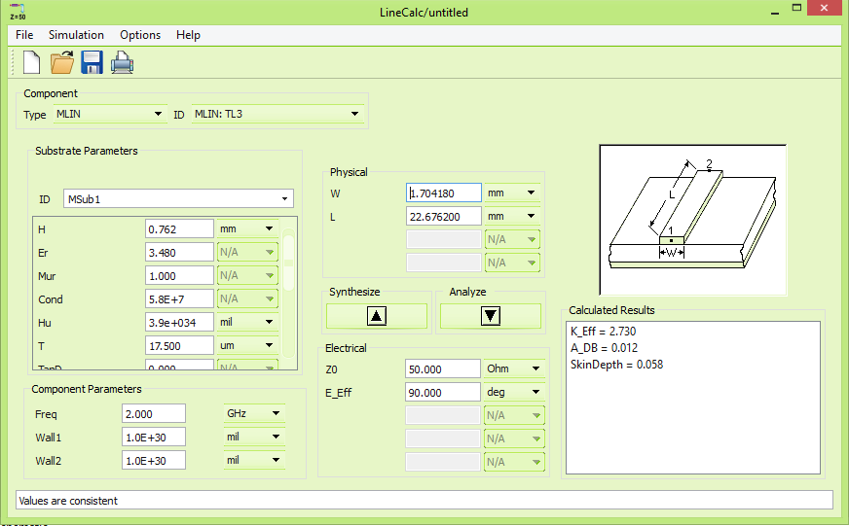

Since we want to measure our circuit using network analyzer, SMA ports are required, but with the SMA port size issue, we need to integrate some transmission line part to our circuit. The participated transmission line must have the characteristic impedance Z0 equal 50 Ohm, which means that its width should be 1.705 mm.

Here we use the MSTEP components to have a better simulation, where the differences in width between 2 part of a microstrip line are counted in. This different in dimension is considered as the discontinuities.  
After that, by using layout generation function of ADS, we were able to get the layout of the filter circuit. Then, we can use ADS EM simulation function which include the electrical magnetic affections to get the result that the circuit may possibly behave in reality.



## Optimized Circuit Momentum Simulation





Now that we were able to get a better result from our momentum, we could proceed to create the circuit. Unfortunately, we was not able to exactly create the circuit. In this case, all we could try is to change the design of the circuit so that it can be realizable. Because we had to increase the distance between two lines of the microstrip couple line component, the coupling coefficient would decrease as well. So our new design coupling coefficient S31 would be -13 dB, which is the nearest to the goal -10 dB.

# Realizing Circuit Design for 13 dB





Realizable Circuit Momentum Simulation





# Comparing the measuring result of the network analyzer with the momentum simulation result





Figure 1 Comparison of reflection coefficient S11



Figure 2 Comparison of coupling coefficient S31



Figure 3 Comparison of transmission coefficient S21



Figure 4 Comparison of isolation S41



Figure 5 Measurement result of the phase shift between port 3 and port 2 of the circuit.

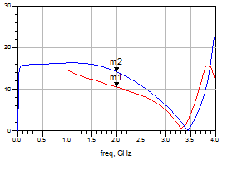

Figure 6 Comparison of the directivity of the circuit

# Conclusion

From the comparison figures, we can see that: in overall, the shape of the measurement results are pretty much the same looking as the simulation result. Although compare to the simulation, the value of the circuit is slightly higher than the simulation. However, this might be explained due to the substrate material and the circuit making process, those errors that we cannot avoid regarding to the material. In the end, our result is acceptable since it is not much different from the initial condition. We can confirm the succession of the project.